Answer Key - My Language Homework – Q2:8
Monday | Tuesday | Wednesday | Thursday
Circle the words that need to be capitalized.  We will be leaving for Colorado on Monday. | Which word could be found on this page of a dictionary?  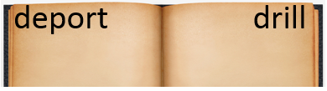  dune  dinner  danger | Circle the words that need to be capitalized.  Emma and Grace are shopping at Walmart. | Which definition matches the underlined word? 1  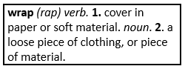  I will wrap my brother’s birthday gift.
What does the underlined word mean? Use the clues in the sentence to help you.  When going to the desert, you should be careful and beware of dangerous snakes.  be careful | Highlight the clue that helped you find the meaning of the word beware.  When going to the desert, you should be careful and beware of dangerous snakes. | Which compound word means “a chair with wheels”?  tablespoon  wheelchair  doghouse | Split the compound word into parts. What does it mean?  yearbook  a book about one year
Fill in the missing plural noun.  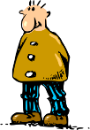  one man  two men | Fill in the missing plural noun.  All the people (person) went home after the show. | Fill in the missing plural noun.  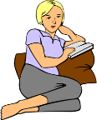  one woman  two women | Fill in the missing plural noun.  My shoes don’t fit my feet (foot) anymore.
The base port means to carry, so the word export means…  to carry out of a country | The prefix sub means under, so the word submerge means…  to put under water | The prefix re means again, so the word rename means…  to name again | The prefix un means not, so the word uncomfortable means…  not comfortable
Write the two words that make the contraction.  I’m I am  isn’t is not | Fill in the missing word using an apostrophe.  The worm belongs to the fish.  It is the fish’s worm | Write the contraction.  she is she’s  they will they’ll | Underline the possessive noun.  The girl’s toy was left in the car.
Which word best completes the sentence?  myself, yourself, himself  I am going to cut ______ a piece of cake after dinner. | Underline the reflexive pronoun in the sentence.  You need to drive yourself to the nearest hospital. | Which word best completes the sentence?  herself, ourselves, themselves  We shouldn’t blame _________ for what happened. | Underline the reflexive pronoun in the sentence.  I could hear her talking to herself.

