Answer Key - My Language Homework – Q2:9
Monday | Tuesday | Wednesday | Thursday
Circle the words that need to be capitalized.  I love to watch fireworks on the Fourth of July. | Which word could be found on this page of a dictionary?  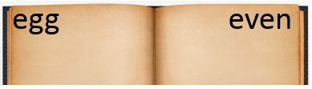  easy  eye  energy | Circle the words that need to be capitalized.  My favorite video game is Minecraft. | Which definition matches the underlined word? 1  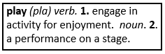  I am going to play with my friend after school.
What does the underlined word mean? Use the clues in the sentence to help you.  Her unique necklace was not like anyone else’s necklace.  different | Highlight the clue that helped you find the meaning of the word unique.  Her unique necklace was not like anyone else’s necklace. | Which compound word means “a house in a tree”?  roadrunner  treehouse  rockslide | Split the compound word into parts. What does it mean?  armchair  a chair with arms
Fill in the missing plural noun.  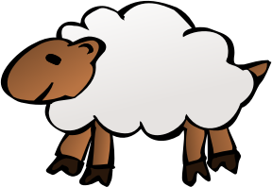  one sheep  two sheep | Write the two words that make the contraction.  didn’t did not  we’ve we have | Fill in the missing plural noun.  All the leaves (leaf) fell off the tree. | Fill in the missing word using an apostrophe.  The chees belongs to the mouse.  It is the mouse’s cheese.
The base port means to carry, so the word import means…  carry into a country | The prefix sub means under, so the word subscribe means…  to go under contract, or agree, to get something regularly | The prefix re means again, so the word remarry means…  to marry again | The prefix un means not, so the word untidy means…  not tidy
Which word best completes the sentence?  myself, yourself, himself  He bought _________ a new baseball glove. | Underline the reflexive pronoun in the sentence.  You need to remind yourself to stay quiet during the movie. | Which word best completes the sentence?  herself, ourselves, themselves  She read to _________ during reading time. | Underline the reflexive pronoun in the sentence.  They can take themselves to the store.
Write the meaning of the suffix –ful.  full of | Make a list of words that end with -ful.  thankful  colorful  joyful | What does the word beautiful mean?  full of beauty | What does the word delightful mean?  full of delight

