Answer Key - My Language Homework – Q2:4
Monday | Tuesday | Wednesday | Thursday
Is the underlined verb Past, Present, or Future tense?  My mom watches my sister dance every Monday. | Write an adjective to describe the face.  sad | Underline the verb in the sentence.  Jamie cooked dinner. | Circle the adjective in the sentence.  The sharp scissors cut the paper.
Circle the words that need to be capitalized.  I ate a Snickers at the movies. | Which word could be found on this page of a dictionary?  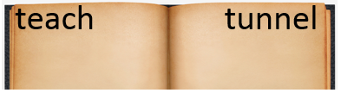  type  truck  tape | Circle the words that need to be capitalized.  Jim lives near Lake Michigan. | Which definition matches the underlined word? 1  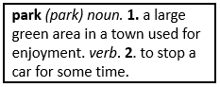  Let’s go play at the park.
What does the underlined word mean? Use the clues in the sentence to help you.  The pool part was postponed because of the thunder storm.  put on hold | Highlight the clue that helped you find the meaning of the word postponed.  The pool part was postponed because of the thunder storm. | Which compound word means “a door in the back of something”?  backpack  backdoor  backbend | Split the compound word into parts. What does it mean?  sweatpants  pants made for sweating
Fill in the missing plural noun.  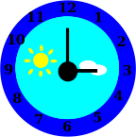  one clock  two clocks | Fill in the missing plural noun.  The teacher read the book to the many children (child). | Fill in the missing plural noun.  one wolf  two wolves | Fill in the missing plural noun.  The room was full of men (man).
The base port means to carry, so the word transport means…  to carry something somewhere | The prefix re means again, so the word redo means…  to do again | The base port means to carry, so the word export means…  to carry out of the country | The prefix re means again, so the word revisit means…  to visit again
Write the two words that make the contraction.  don’t do not  I’m I am | Write the contraction.  cannot can’t  we are we’re | Write the two words that make the contraction.  who’s who is  that’s that is | Write the contraction.  I have I’ve  is not isn’t

