Monday | Tuesday | Wednesday | Thursday
Add ending punctuation to the sentence.  The pencil is broken. | Add ending punctuation to the sentence.  I hate broccoli! | Add ending punctuation to the sentence.  When will Amy be finished? | Add ending punctuation to the sentence.  I am going to learn to play the piano.
Is the underlined noun Singular or Plural?  My friend is coming over today. | Underline the nouns in the sentence.  The clock needs batteries. | Is the underlined noun Singular or Plural?  The students played at recess. | Underline the nouns in the sentence.  My pencil is in my desk.
Is the underlined verb Past, Present, or Future tense?  She reads her book at night. | Underline the verb in the sentence.  We finished the movie. | Is the underlined verb Past, Present, or Future tense?  James will write a letter to the teacher. | Underline the verb in the sentence.  My mom will cook pasta tonight.
Write an adjective to describe the tree.  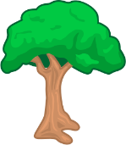  tall  answers will vary | Circle the adjective in the sentence.  The small dog ran. | Write an adjective to describe the watch.  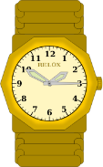  shiny  answers will vary | Circle the adjective in the sentence.  I lost my green marker.
Circle the words that need to be capitalized.  School starts after Labor Day. | Circle the words that need to be capitalized.  I am going to Walmart to buy a DVD. | Circle the words that need to be capitalized.  I drove through the mountains in Colorado. | Circle the words that need to be capitalized.  We ate hamburgers at McDonalds.
Circle the compound words.  backseat  school  sometime  doghouse  student  pencil | Which compound word means “a house for a dog”.  doghouse | Split the compound word into parts. What does it mean?  backpack  a pack you carry on your back. | Split the compound word into parts. What does it mean?  homework  work you do at home
ANSWER KEY – Q1:2

