Answer Key - My Language Homework – Q2:7
Monday | Tuesday | Wednesday | Thursday
Circle the words that need to be capitalized.  I love to eat turkey on Thanksgiving. | Which word could be found on this page of a dictionary?  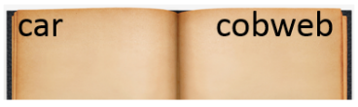  clean  crawl  cups | Circle the words that need to be capitalized.  We will be visiting my family in New York for Hanukah. | Which definition matches the underlined word? 2  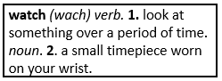  My new watch is made of gold.
What does the underlined word mean? Use the clues in the sentence to help you.  The boat sailed calmly on the tranquil lake.  calm, peaceful | Highlight the clue that helped you find the meaning of the word tranquil.  The boat sailed calmly on the tranquil lake. | Which compound word means “any time after noon”?  afternoon  downstairs  anywhere | Split the compound word into parts. What does it mean?  lampshade  a shade for a lamp
Fill in the missing plural noun.  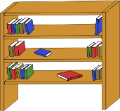  one shelf  two shelves | Fill in the missing plural noun.  The children (child) are going on a fieldtrip. | Fill in the missing plural noun.  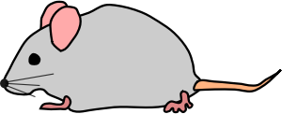  one mouse  two mice | Fill in the missing plural noun.  The three deer (deer) ran through the forest.
The base port means to carry, so the word support means…  to carry to weight of something | The prefix un means not, so the word unreal means…  not real | The prefix re means again, so the word remake means…  to make again | The prefix un means not, so the word uncommon means…  not common
Write the two words that make the contraction.  can’t cannot  we’re we are | Fill in the missing word using an apostrophe.  The eraser belongs to the pencil.  It is the pencil’s eraser. | Write the contraction.  he will he’ll  they are they’re | Underline the possessive noun.  The cat’s stripes are orange.
Write the meaning of the prefix sub-  under | Make a list of words that start with sub-.  subject  subfreezing  substitute | What does the word subway mean?  a passageway under the ground | What does the word submarine mean?  a watercraft that stays under water

