Answer Key - My Language Homework – Q3:6
Monday | Tuesday | Wednesday | Thursday
Circle the words that need to be capitalized.  We got a big tree for Christmas. | Which word could be found on this page of a dictionary?  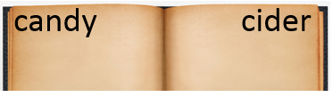  copy  chair  crop | Split the compound word into parts. What does it mean?  campfire  a fire used at a camp site | Which definition matches the underlined word? 1  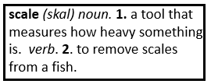  Step on the scale to see how much you weigh.
What does the underlined word mean? Use the clues in the sentence to help you.  The boy ran rapidly to his dad after not seeing him for four weeks.  quickly, fast | Highlight the clue that helped you find the meaning of the word rapidly.  The boy ran rapidly to his dad after not seeing him for four weeks. | Write the contraction.  what is what’s  he will he’ll | Fill in the missing plural noun.  The waves (wave) were big at the beach.
Fill in the missing past tense verb.  I brought (bring) my teacher an apple. | Which word best completes the sentence?  himself, herself, myself  She can measure __________ with the yardstick. | Fill in the missing past tense verb.  I built (build) a tower out of Legos. | Write the possessive noun.  The book belongs to my mom.  It is my mom’s book.
The suffix ly means in this way, so the word angrily means…  in an angry way | The prefix re means again, so the word reorganize means…  to organize again | The prefix pre means before, so the word pretest means…  to test before | The root port means to carry, so the word import means…  to carry into a country
Is the underlined word an adjective or adverb?  The wet dog ran through the house. | Fill in the blank with an adverb.  The dog quickly ate all of his food. | Is the underlined word an adjective or adverb?  He quietly chewed on his dog bone. | Fill in the blank with an adjective.  The loud dog barked out the window.
Is the language below formal or informal?  Will you be joining me at my party? | Is the language below formal or informal?  Are you comin to the party? | Is the language below formal or informal?  Thank you | Is the language below formal or informal?  Thanks

