Answer Key - My Language Homework – Q3:1
Monday | Tuesday | Wednesday | Thursday
Circle the words that need to be capitalized.  My birthday is in February. | Which word could be found on this page of a dictionary?  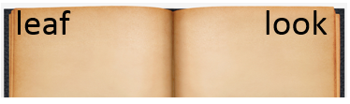  lucky  lazy  lift | Circle the words that need to be capitalized.  We are going to visit Disney World this summer. | Which definition matches the underlined word? 1  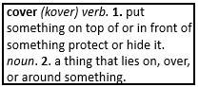  Please cover yourself before going outside.
What does the underlined word mean? Use the clues in the sentence to help you.  I could smell the lovely aroma of the fresh baked cookies.  smell | Highlight the clue that helped you find the meaning of the word aroma.  I could smell the lovely aroma of the fresh baked cookies. | Which compound word means “a cup used for tea”?  teapot  tealeaf  teacup | Split the compound word into parts. What does it mean?  bookshelf  a self for books
Fill in the missing plural noun.  one child  two children | Write the two words that make the contraction.  doesn’t does not  we’re we are | Fill in the missing plural noun.  All the wolves (wolf) howled in the night. | Underline the possessive noun.  The boy’s book is scary.
The base port means to carry, so the word portable means…  able to be carried | The prefix sub means under, so the word subway means…  an underground passageway. | The suffix ful means full of, so the word useful means…  full of use | The prefix un means not, so the word uncertain means…  not certain
Which word best completes the sentence?  myself, yourself, himself  I am going to make _________ a sandwich. | Underline the reflexive pronoun in the sentence.  He bought himself a new pair of jeans. | Which word best completes the sentence?  herself, ourselves, themselves  They should buy _______________ some lunch. | Underline the reflexive pronoun in the sentence.  We covered ourselves in sunscreen before playing outside.
Write the meaning of the suffix –less.  without | Make a list of words that end with -less.  worthless  tireless  speechless | What does the word fearless mean?  without fear | What does the word odorless mean?  without odor

