Name: Weekly Language Review – Q2:2 Date:
Monday | Tuesday | Wednesday | Thursday
Add ending punctuation to the sentence.  What time should we leave | Is the underlined noun singular or plural?  My cats love to play with yarn. | Add ending punctuation to the sentence.  I would like to buy some gum at the store | Underline the nouns in the sentence.  I use crayons to draw pictures.
Is the underlined verb past, present, or future tense?  My friend and I played after school. | Write an adjective to describe the cookie. | Underline the verb in the sentence.  My aunt will drive me to school tomorrow. | Circle the adjectives in the sentence.  Her car is small and red.
Circle the words that need to be capitalized.  my friend lives in canada. | Which word could be found on this page of a dictionary?  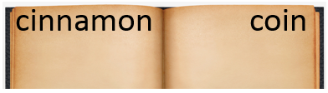  car  cucumber  clean | Circle the words that need to be capitalized.  We are going to light fireworks on new year’s eve. | Which definition matches the underlined word?  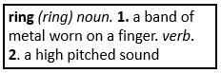  You can ring the doorbell to see if anyone is home.
What does the underlined word mean? Use the clues in the sentence to help you.  I drank a huge glass of water because I was so parched. | Highlight the clue that helped you find the meaning of the word parched.  I drank a huge glass of water because I was so parched. | Which compound word means the light from the moon?  footprint  sunshine  moonlight | Split the compound word into parts. What does it mean?  sunshine
Fill in the missing plural noun.  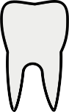  one tooth  two ________________ | Fill in the missing plural noun.  The four _____________ (goose) flew over the pond. | Fill in the missing plural noun.  one child  two ________________ | Fill in the missing plural noun.  The farmer had to gather all of his ___________ (sheep) before the storm.
Write the meaning of the prefix re-. | Make a list of words that start with re-. | What does the word reread mean? | What does the word rewrite mean?

