Answer Key - My Language Homework – Q2:1
Monday | Tuesday | Wednesday | Thursday
Add ending punctuation to the sentence.  I would like to read a new book tonight. | Is the underlined noun Singular or Plural?  What movie do you want to watch? | Add ending punctuation to the sentence.  Wait for me! | Underline the nouns in the sentence.  Angie and her sister are in the house.
Is the underlined verb Past, Present, or Future tense?  The dog runs around every day. | Write an adjective to describe the puppy.  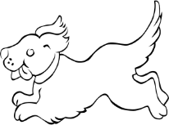  playful | Underline the verb in the sentence.  I brushed my teeth and tied my shoes. | Circle the adjective in the sentence.  My sparkly pencil is in my desk.
Circle the words that need to be capitalized.  I visited Nevada, and saw the Grand Canyon. | Which word could be found on this page of a dictionary?  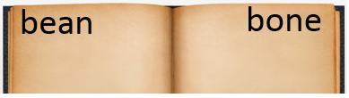  bump  binder  baby | Circle the words that need to be capitalized.  I went shopping at Home Depot for some new plants. | Which definition matches the underlined word? 1  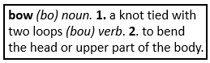  I put a big bow on the birthday present.
Circle the compound words.  stable  horseback  fence  pillow  campfire  everything | Which compound word means “a fire at a camp”?  campfire | Split the compound word into parts. What does it mean?  bedtime  time for bed | Split the compound word into parts. What does it mean?  bathrobe  a robe used before or after a bath
What does the underlined word mean? Use the clues in the sentence to help you.  She was flabbergasted, or shocked, when she won first place in the art contest.  shocked | Highlight the clue that helped you find the meaning of the word flabbergasted.  She was flabbergasted, or shocked, when she won first place in the art contest. | What does the underlined word mean? Use the clues in the sentence to help you.  She tried to conceal her face by hiding behind big sunglasses.  hide | Highlight the clue that helped you find the meaning of the word conceal.  She tried to conceal her face by hiding behind big sunglasses.
Fill in the missing plural noun.  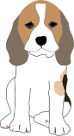  one puppy  two puppies | Fill in the missing plural noun.  one foot  two feet | Fill in the missing plural noun.  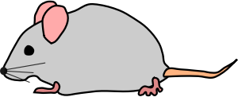  one mouse  two mice | Fill in the missing plural noun.  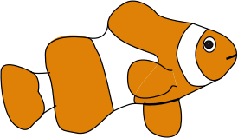  one fish  two fish

