Answer Key - My Language Homework – Q1:5
Monday | Tuesday | Wednesday | Thursday
Add ending punctuation to the sentence.  Plants need the sun to live. | Is the underlined noun Singular or Plural?  Her hat is red. | Add ending punctuation to the sentence.  What time is lunch? | Underline the nouns in the sentence.  Can I borrow your pencil and eraser?
Is the underlined verb Past, Present, or Future tense?  She played the game all day. | Underline the verbs in the sentence.  The dog barks at night. | Is the underlined verb Past, Present, or Future tense?  Emma reads every day. | Underline the verbs in the sentence.  I will see you tomorrow.
Write an adjective to describe the bed.  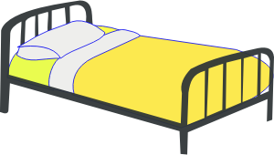  comfortable  answers will vary | Circle the adjective in the sentence.  The pillow is soft. | Write an adjective to describe the coins.  gold  answers will vary | Circle the adjective in the sentence.  She ran around the big backyard.
Circle the words that need to be capitalized.  I rode a boat down the Mississippi River. | Circle the words that need to be capitalized.  The milkshakes at Burger King are the best. | Circle the words that need to be capitalized.  This Monday is President’s Day. | Circle the words that need to be capitalized.  My favorite game is Minecraft.
Circle the compound words.  yogurt  strawberry  banana  toothbrush  basketball  tooth | Which compound word means “a brush you use on your teeth”?  toothbrush | Split the compound word into parts. What does it mean?  footprint  a print made by a foot | Split the compound word into parts. What does it mean?  homemade  something made at home
Circle the word that is spelled incorrectly? Write the correct spelling.  Please do not walk neer the fire.  near | Which word could be found on this page of a dictionary?  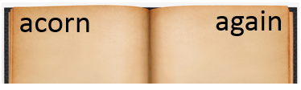  address  apron  absent | Circle the word that is spelled incorrectly? Write the correct spelling.  I love learning at skool.  school | Which word could be found on this page of a dictionary?  tune  tap  time

